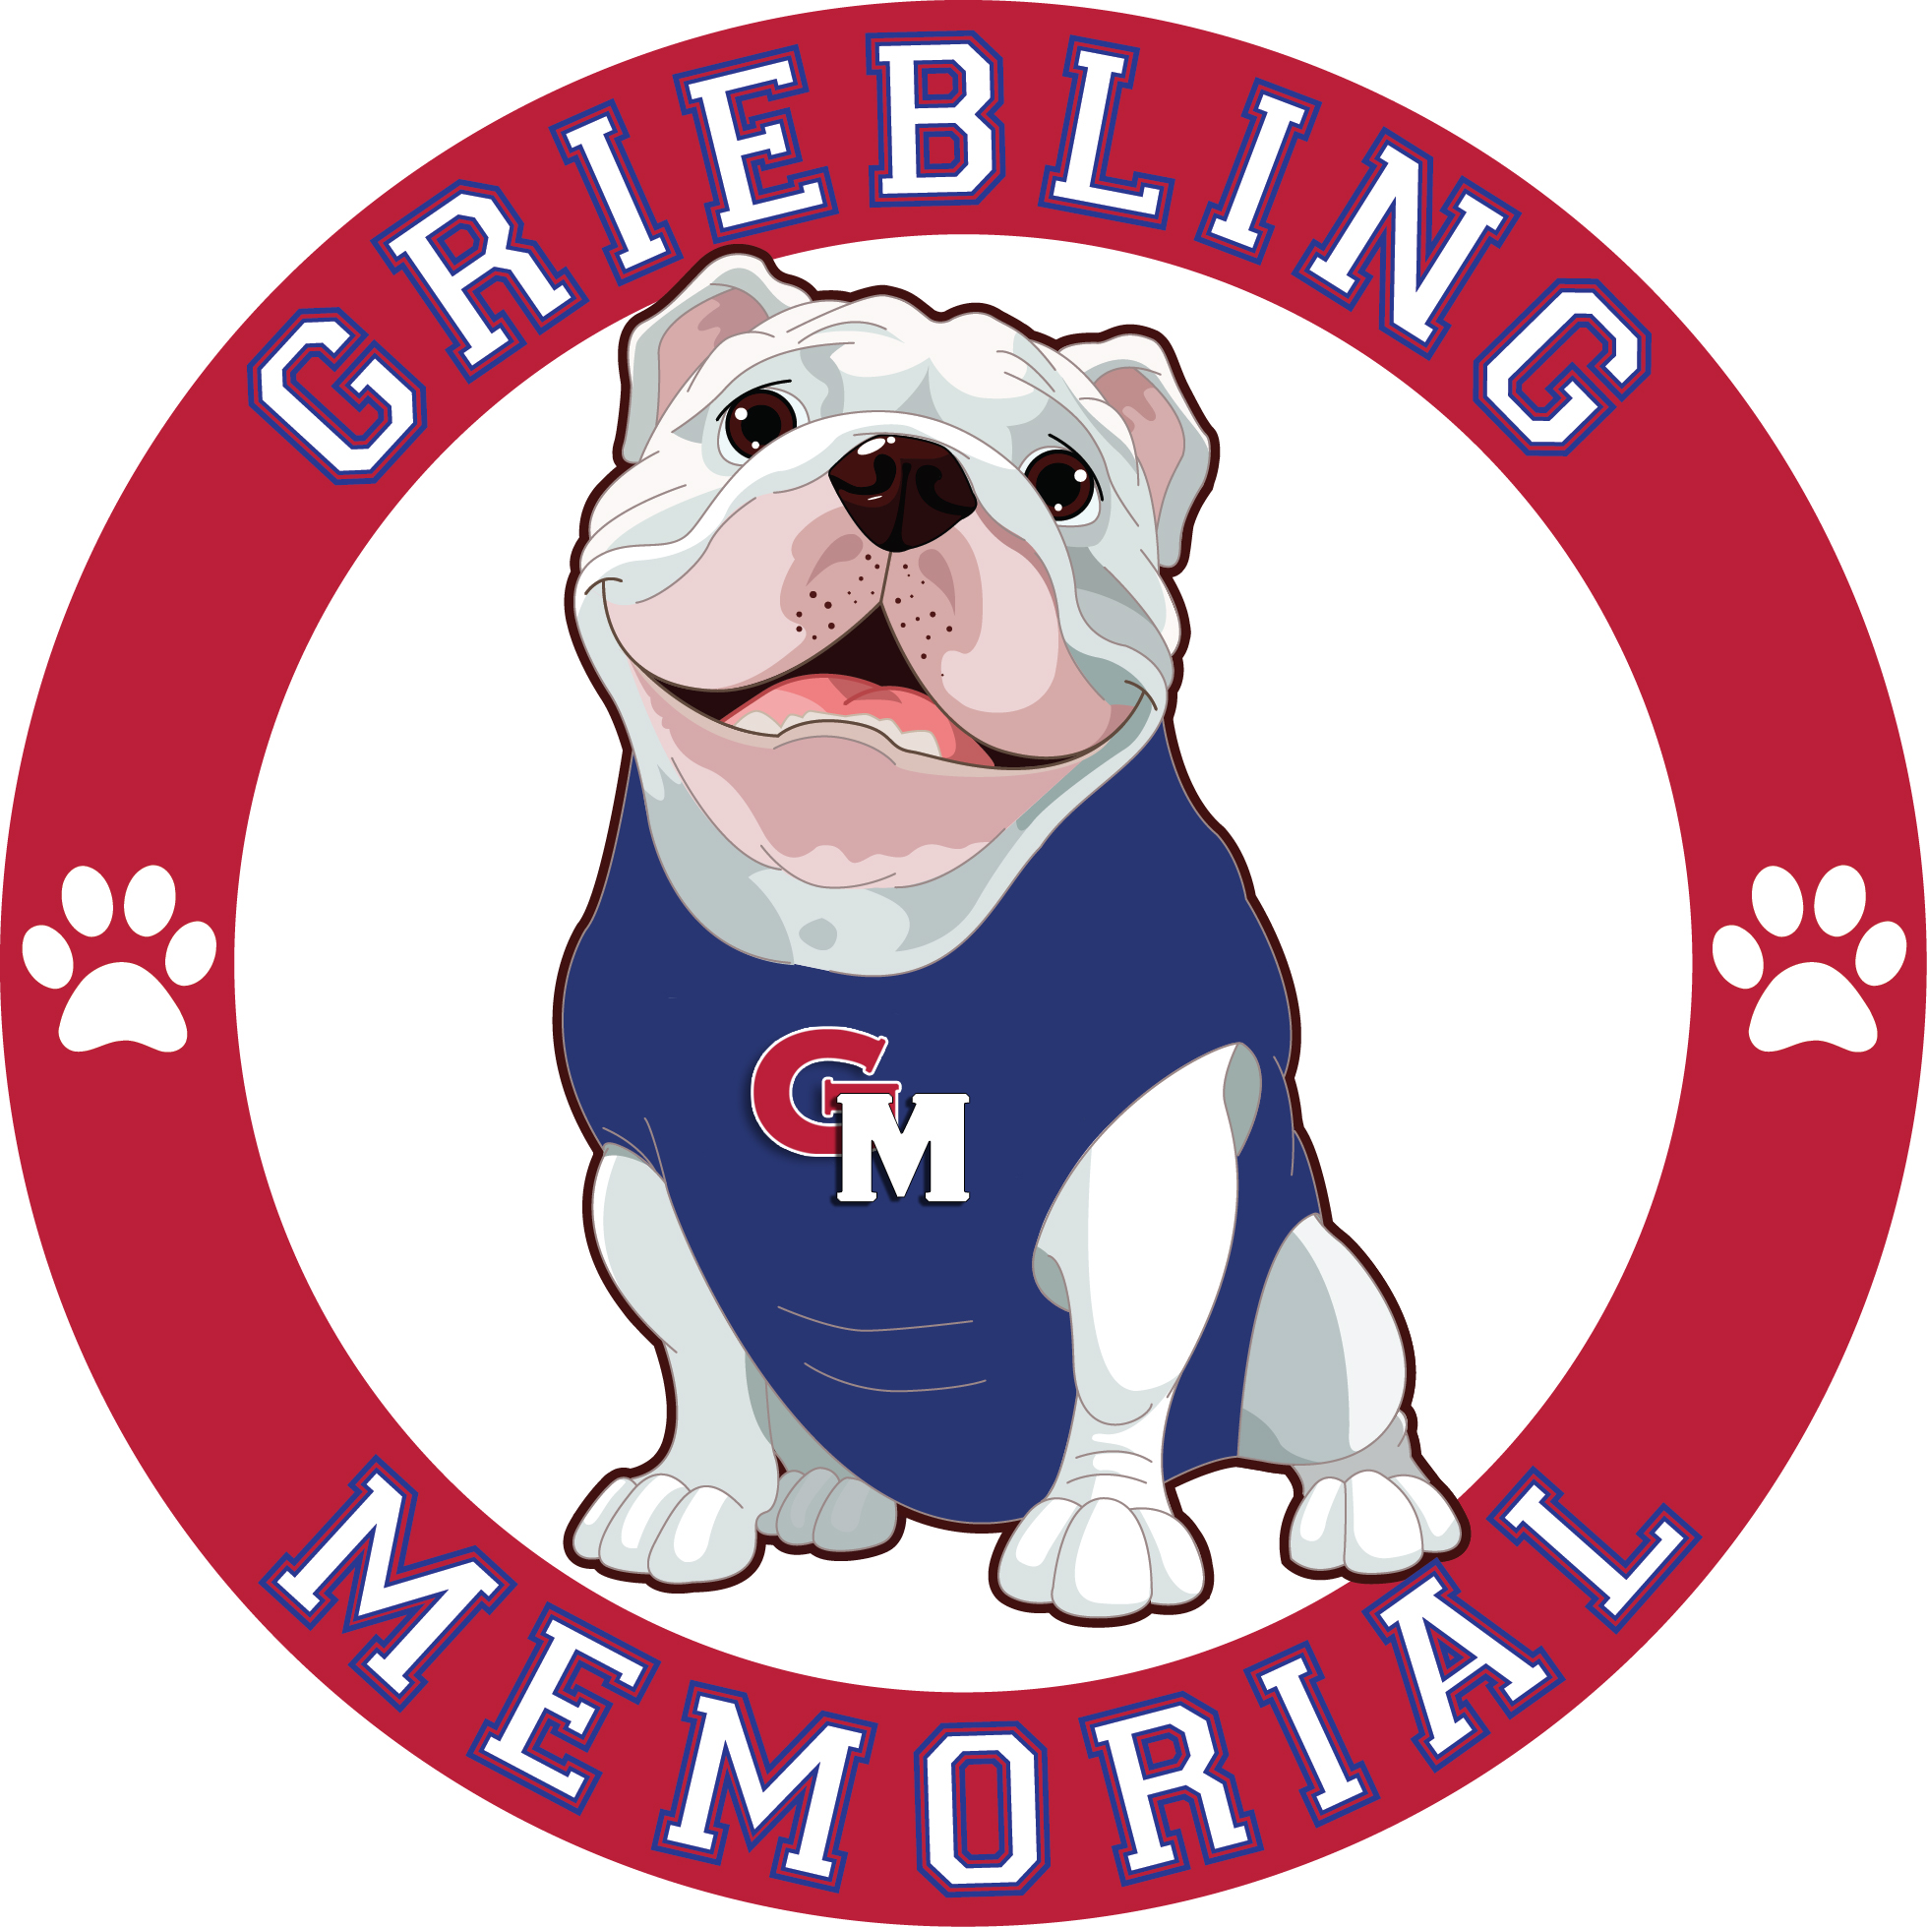C:\Users\Julianne\AppData\Local\Microsoft\Windows\Temporary Internet Files\Content.IE5\CVHT61F7\MCFD01017_0000[1].wmf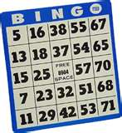

GRIEBLING-MEMORIAL

**FAMILY PIZZA BINGO NIGHT**

**COME FOR DINNER**

Pre-order a freshly made cheese pizza (whole or by the slice)

Beverages will be available for purchase

Soda, large water and Gatorade - $1.00 EACH

**AND LET’S PLAY BINGO!**

**When:** Friday, January 11, 2019 from 6:00PM to 7:30PM **(Weather Permitting)**

**Where:** Memorial School Cafeteria

**Who:** The Whole Family

Please complete the order form below and return to your child’s teacher by **January 4, 2019**

**Last year’s event was a sell-out, so reserve your seat early!**

If you have any questions, please call: Sandy Iacono at (917) 349-5602 or Paula Machado at (347) 244-5052

**REMINDER:** THE PTA WILL BE SELLING PRE-SALE GIFT AUCTION TICKETS!

**PIZZA PRE-ORDER FORM**

Family Name & Phone: \_\_\_\_\_\_\_\_\_\_\_\_\_\_\_\_\_\_\_\_\_\_ Teacher’s Name: \_\_\_\_\_\_\_\_\_\_\_\_\_\_\_\_\_\_\_\_

Number of Adults: \_\_\_\_\_\_\_\_\_\_\_\_\_\_\_\_\_\_\_\_\_\_\_\_ Number of Children: \_\_\_\_\_\_\_\_\_\_\_\_\_\_\_\_\_

Whole Large Cheese Pizza $13.00 x \_\_\_\_\_=\_\_\_\_\_\_

Cheese Pizza Slices $2.00 x \_\_\_\_\_=\_\_\_\_\_\_\_

TOTAL ENCLOSED\_\_\_\_\_\_\_\_\_\_

Please return this form with your payment in an envelope labeled **Pizza Bingo Night.**

Please make checks payable to **Griebling Memorial PTA.**