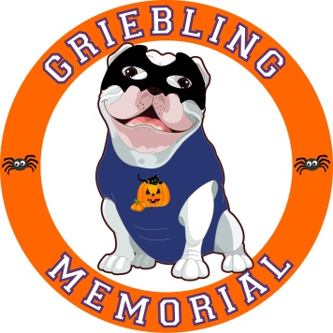Griebling-Memorial’s 5th Annual Trunk or Treat
Saturday, October 27th, 1:00pm-3:00pm
(Rain date Sunday, October 28th, 1:00pm-3:00pm)

Join us for an afternoon of Family Fun!
DJ -­‐ Trunk or Treating -­‐ Halloween Games -­‐ Prizes Awarded for
Best Decorated Trunk.

$10.00 per Car Spot, Family, or Walk-in
This event is open to Griebling and Memorial families.

A Trunk or Treat is a Halloween event where people gather and park their cars in a large parking lot. They open their trunks, or the backs of their vehicles, and decorate them. Children then travel from car to car “trunk or treating.” The event provides a safe environment for trick or treaters and their families.

Reservations are limited and spots will be given to those who register ﬁrst. You can register as a walk-in if you cannot arrive by 1:20pm or need to leave prior to 3:00pm.
Memorial parking lot opens at 1:00pm. Cars will have to be parked and ready for "trunk or treating” by 1:30pm.

If you do not wish to participate in the trunk decorating, but would still like to join the party, the cost per family is $10.00 (pre‐registration with this form required). Tables will be set up so walk-in families can provide candy.

Each child registered per family will be given a wristband that will allow him/her to be included in all trunk or treating fun. Children cannot be left unattended or dropped oﬀ at this event.

Pre-registration for all cars is required. For the safety of the children, no cars will be able to leave the parking lot until 3:00pm. No unregistered children will be allowed.

In the event of rain on October 27th, parents will be notified via school messenger the day before. Also check your Remind App and our Griebling-Memorial Facebook page of the date change to October 28th.

Family Name(s):__________________________________________________________________

Email: __________________________________________________________________________

Car Make and Model or Walk-in:______________________________________________________

Number of Children in Family: ________________________________________________________

Payment is due with registration, please make checks payable to Griebling-Memorial PTA Questions: Contact Ilene Palmieri at Ilenepalmieri@gmail.com

