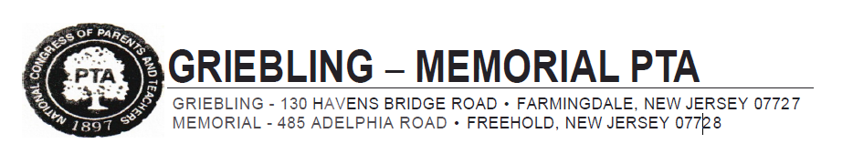

Donation Receipt for Clothing Drive Fundraiser
Griebling - Memorial PTA
130 Havens Bridge Road
Farmingdale, NJ 07727
grieblingmemorialpta.com
Charity Registration #CH142530
EIN #51-0250595

Date donation received: _____________________________________________
Donated by: _____________________________________________________
Address: ________________________________________________________

Date receipt issued: _____________________________
PTA Treasurer: Jen Polotti: jenpolotti@gmail.com
PTA President: Jessica Valentino jvalen75@gmail.com

