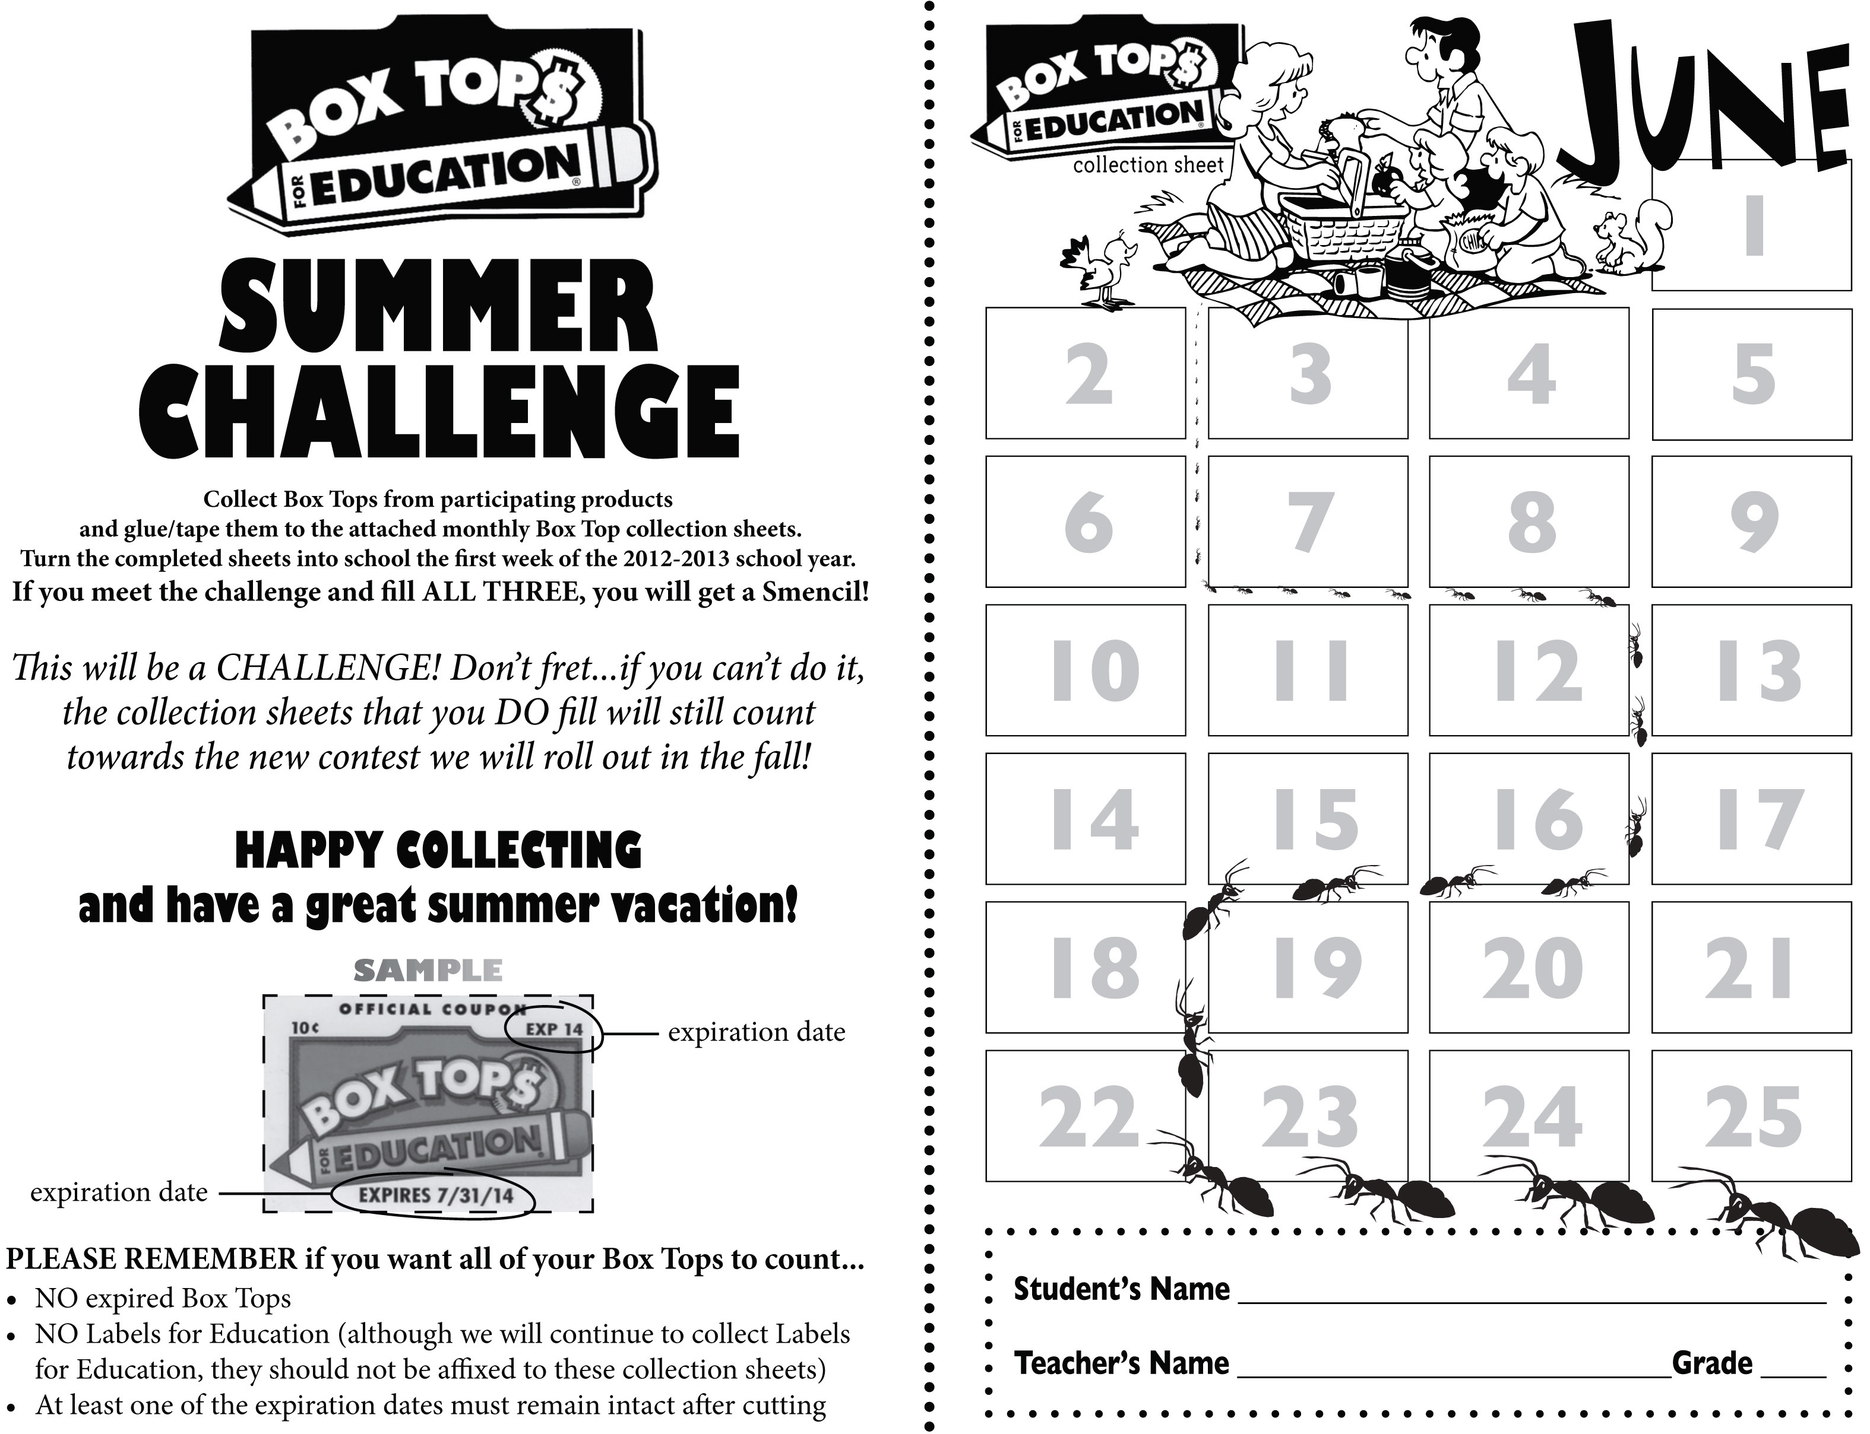

Summer reward will be a Griebling T-Shirt!

There will be a winner from each grade. Hand in your box tops the first week of school.

Deadline for submission is **September 15, 2014**.